**Merge PDFS Utility – Hand Guide**

**Objective:**

This document will explain how we can use the Merge PDF utility tool to merge multiple PDFs into a single combined PDF.

**Pre-requisite:**

This tool has some pre- requisite before moving ahead with the utility. You need to create a similar folder structure as shown below (for better output).

1. Have a mother folder say, MergePDF
2. Have two sub-folders inside it. Input, Output as shown below.

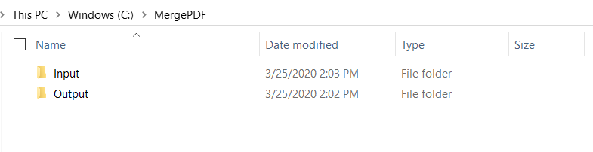

**Installation:**

1. Unzip **MergePDFS.zip** zipped file in your desktop selecting ‘*Extract Here*’. Once you unzip, a folder named **MergePDFS** appear in your desktop.

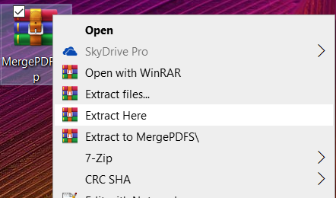

1. Inside **MergePDFS** folder you have two files as shown below. Just double click on the MergePDFS.exe and the merge utility tool appears on the screen.

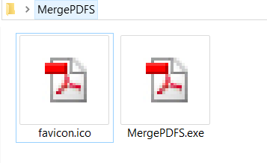

**Note:** This utility tool don’t require any installation step and it will appear as a window where you need to specify certain inputs to consolidate and generate a merge PDF.

*Every time you want to regenerate a merge PDF, just double click on MergePDFS.exe and provide the inputs.*

1. The below window appears.

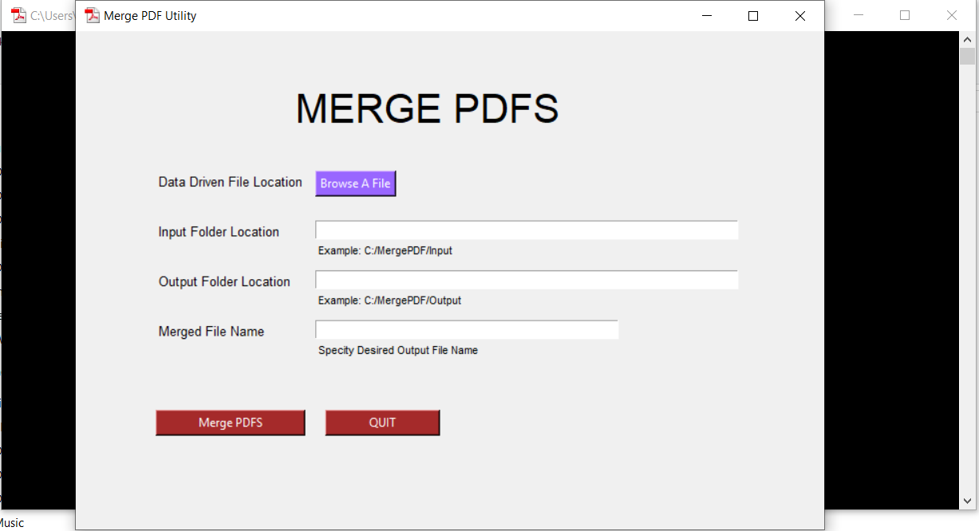

**Merge PDFS step by step:**

Please follow the below steps to merge the PDFS into a single custom PDF in your local PC.

1. Choose the Data Driven excel/csv File *by clicking Browse a File*. In my case I have kept the file under *C Drive 🡪 Merge PDF 🡪 Input* as shown below.

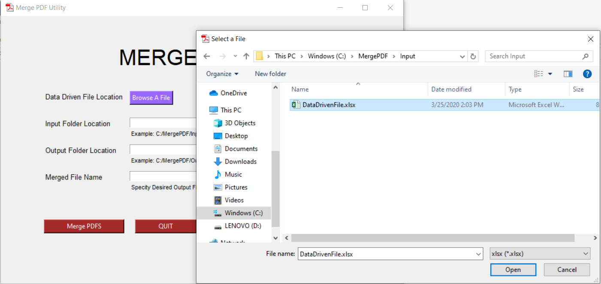

1. Once you choose the file, the Select dialog will close and it will look as below:

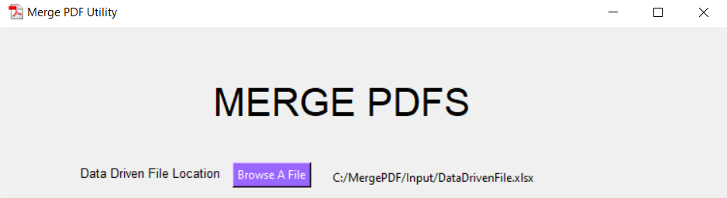

1. Next you need to input the input folder and output folder location.

**Input Folder Location:** Location where you have all the individual files generated by Power BI

**Output Folder Location:** Location where you want to have the consolidated merged output

**Merged File Name**: Desired Filename of the merged output

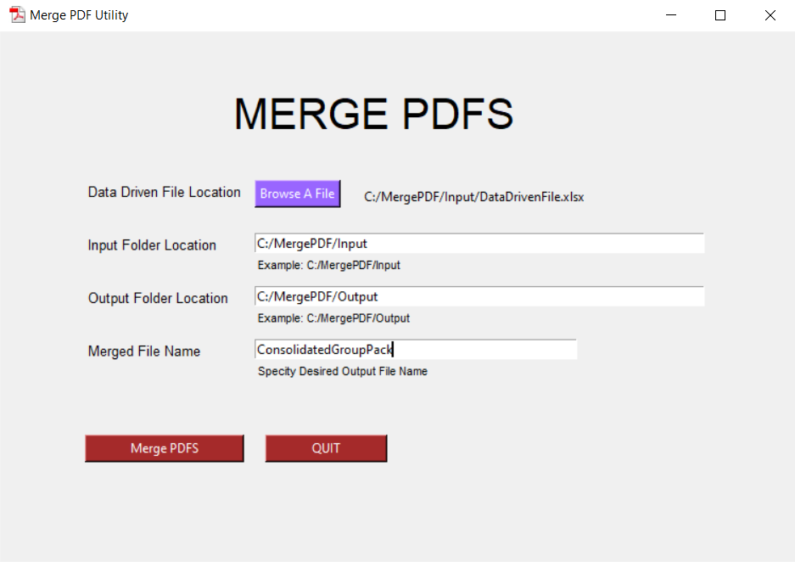

1. Once provided with all the inputs, click on **Merge PDFS** button. The utility will merge all the individual pdfs inside the Input Folder and generate the consolidated output in the Output Folder with the specified name. On successfully merge, it will show below message.

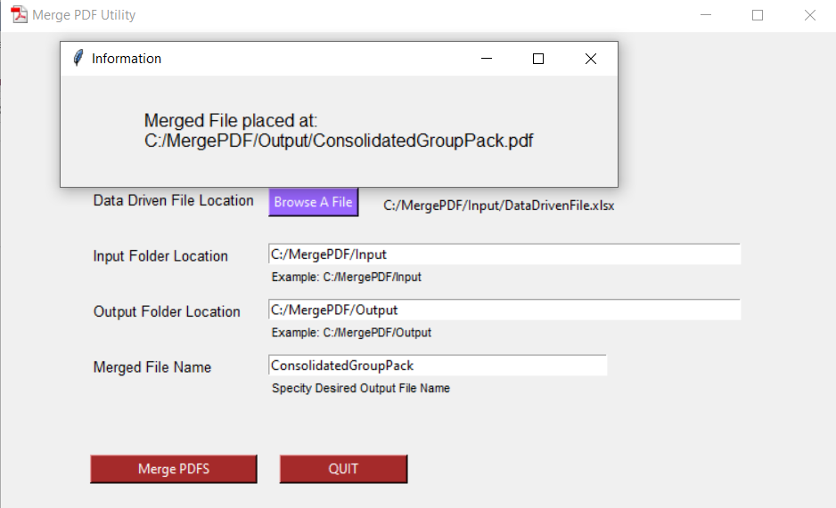

1. You can validate the output going to the specific folder and opening the consolidated pdf. In my case the output is generated at below location.

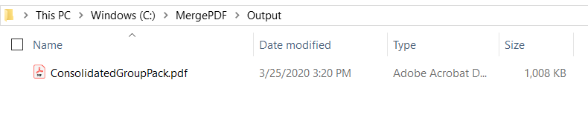

1. To quit the application, just press on **QUIT** after the merge is successfully completed.

**Warnings:**

Below warnings scenarios are to make sure user enters all the inputs properly.

1. The merge PDF utility will not work unless you provide all the values as shown above. If proceed without providing values it will show a warning message as below.

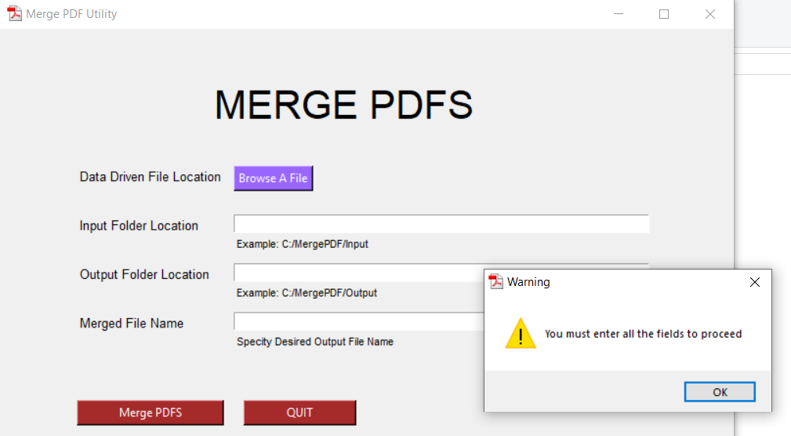

1. If you don’t provide the input/output folder path properly, i.e. if the paths provided don’t exist in your computer, it will throw below warning message.

